芭提雅内装

产品 | 图样 | 规格 | 单价 | 数量 | 总价 | 备注 | 链接
 |  |  |  |  |  |  | https://item.taobao.com/item.htm?spm=a230r.1.14.50.7d7f38a5wkwlEk&id=605494071885&ns=1&abbucket=13#detail
床垫 | 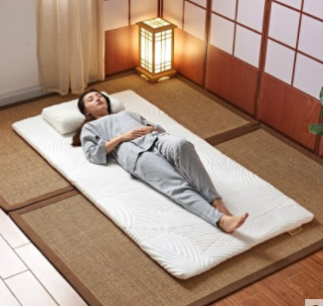 |  |  | 1 |  |  | https://detail.tmall.com/item.htm?id=600597645975&ali_refid=a3_430583_1006:1103777447:N:Of8OADt8+ul56jNNNMhV2bFYlVAekq/E:7c67b734c3eee4d61ffb56f5414c3e0e&ali_trackid=1_7c67b734c3eee4d61ffb56f5414c3e0e&spm=a230r.1.14.1&skuId=4197279316662
鞋柜 | 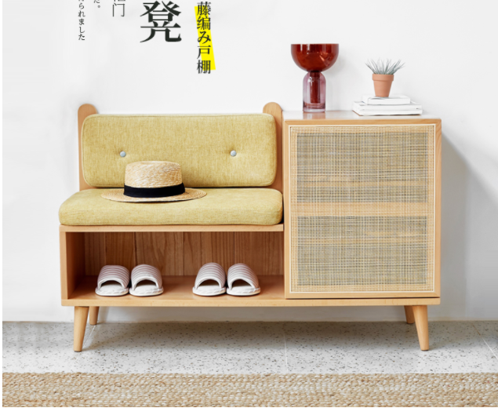 | 1100*400*705mm | 1620 | 1 | 1620 |  | https://detail.tmall.com/item.htm?spm=a1z10.3-b-s.w4011-15423722056.73.46c578ecjolMFJ&id=585899748548&rn=8c1aba62bdd7a72d4305efedc04a6814&abbucket=5
衣架 | 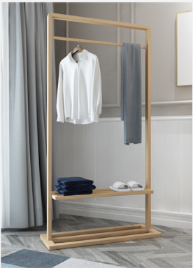 | 85*32*160cm | 277.20 | 1 | 277.20 |  | https://item.taobao.com/item.htm?spm=a230r.1.14.1.22e519fdvUij6j&id=562686080726&ns=1&abbucket=13#detail
茶几 | 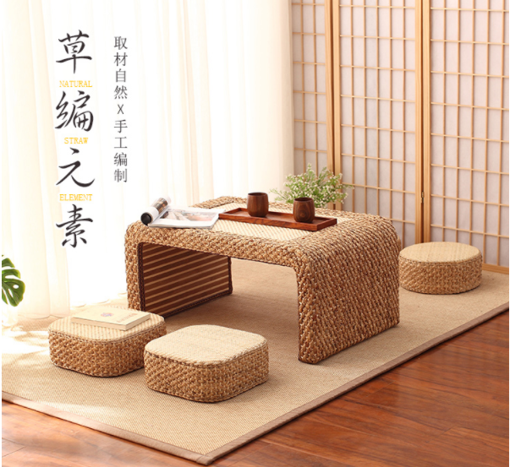 | 小号茶几 60*45*30cm  茶几坐垫  高13cm直径30cm | 498 | 1 | 498 |  | https://item.taobao.com/item.htm?id=585937996890&ali_refid=a3_430585_1006:1110312056:N:6c%2BuMxUAKc6cfT97ydqJde1qoScIPdwi:6d1b63c59b85a0dfc4ec6b036fb252f6&ali_trackid=1_6d1b63c59b85a0dfc4ec6b036fb252f6&spm=a230r.1.14.11#detail
客厅灯 | 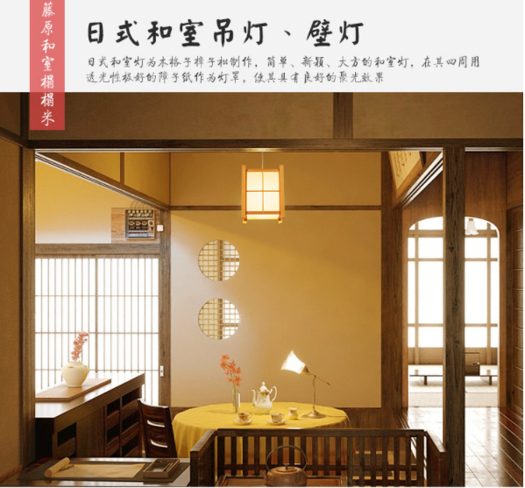 | 30cm*21cm | 128 | 1 | 128 |  | https://detail.tmall.com/item.htm?spm=a1z10.3-b-s.w4011-14442803642.97.6f3564b9nRyacY&id=531174284128&rn=36ee498a203b6cca6f603cabb8ec92f1&abbucket=5&skuId=3166166773949
合计 |  |  |  |  | 10634.50

